Contract Number *(VA-210625-CAI)*

Contents

STATEMENT OF REQUIREMENTS (SOR) 2

|  |
| --- |
| **STATEMENT OF REQUIREMENTS (SOR)** **SOR # VDOT-240701-01-CAI**  ***VDOT Professional Services Procurement Office Solution (PSPO - #942 & 1140)*** |

1. **Date:** July 1, 2024
2. **Authorized User**: Virginia Department of Transportation
3. **Authorized User Contact Information:**

*Priya Saldanha, Assistant Division Administrator*

*1401 E. Broad Street*

*Richmond, VA 23219*

Phone: 804-335-4135

E-mail: priya.saldanha@vdot.virginia.gov

Fax: 804-786-2019

PLEASE NOTE: ALL questions related to this SOR should be directed to the CAI Account Manager. Suppliers may NOT contact the Authorized User.

1. **Solicitation Schedule:**

|  |  |
| --- | --- |
| **Event** | **Date** |
| Release SOR | July 17, 2024 |
| Supplier Questions Due to CAI | July 31, 2024 |
| Authorized User Responds to Questions | August 7, 2024 |
| Supplier Response Due | August 28, 2024 |
| Award Decision | October 14, 2024 |
| Estimated Project Start Date | October 28, 2024 |

1. **Evaluation and Scoring**

Supplier’s Response must be submitted in the specified Statement of Work (SOW) format and will be evaluated for format compliance.

Supplier’s Response will be evaluated for technical merit based on its appropriateness to the performance of Authorized User’s requirements, its applicability to the environment, and its effective utilization of Supplier and Authorized User’s resources.

1. **Project/Service:**

942 & 1140 Professional Services Procurement Office Solution

1. **Specialty Area** (Check one)**:**

|  |  |
| --- | --- |
| Application Development | Information Security |
| Business Continuity Planning | IT Infrastructure |
| Business Intelligence | IT Strategic Planning |
| Business Process Reengineering | Project Management |
| Enterprise Architecture | Public Safety Communications |
| Enterprise Content Management | Radio Engineering Services |
| Back Office Solutions | IV&V Services |
| Geographical Information Systems |  |

1. **Contract Type: Fixed Price, Deliverable-based**
2. **Introduction:**

Project History

VDOT is seeking a supplier to implement a single solution contract management platform for all aspects of the professional services solicitation and contract administration.

The single solution must provide for managing and monitoring the entire lifecycle of contracts for professional architecture and engineering services (#1140) which must also include obtaining information needed for procurement, obtaining invoice information, and sending approvals (#942).

Professional services are procured statewide within the Virginia Department of Transportation (VDOT), primarily by the following Divisions:

• Construction

• Environmental

• Location and Design

• Materials

• Right of Way and Utilities

• Structure and Bridge

• Traffic Operations

• Transportation and Mobility Planning

Business Need

Managing professional service contracts involves multiple stages, including procurement, contract award and payment reviews and approvals, renewals, change orders, monitoring and reporting, compliance, issuing and approving task orders, closeout, and performance evaluations.

Today, these stages often require highly manual and redundant processes. There is no way to easily gain insight into statuses, capacity, or other information needed for the strategic management of professional services consultant contracts, including future planning, quality assurance, and compliance. Furthermore, there is no centralized location for all VDOT staff to view the active, open or closed contracts. As a result, PSPO does not have access to the necessary documents and data on agency professional services consultant contracts.

Project Complexity

Medium to High Risk

Project Management and Organizational Structure

The VDOT Project Manager and the Supplier Project Manager are the main VDOT points of contact and are responsible for day-to-day management of the application solution.

More Specifically:

1. Supplier shall appoint a Project Manager
2. The supplier Project Manager shall report to the VDOT Project Manager
3. VDOT Project Manager shall escalate issues needing supplier attention to the supplier

Project Manager, who will escalate within supplier’s organization as needed

1. Supplier Project Manager shall copy the VDOT Project Manager on all

communications with VDOT staff.

1. **Scope of Work:**

This SOR defines the services required by Authorized User in support of the Project/Service.

In Scope:

* Supplier will provide the following services:
* Create replacement PSPO application using Microsoft Dynamics 365 modules available to VDOT as the application platform.
* Provide information regarding license types and quantity count for the intended solution.
* Configure Dynamics 365 to provide all functionality required; minimal custom development is desired outside of native power platform functionality. See the Fit/Gap of requirements compared to Dynamics functionality for more details regarding the required customizations
* Configure every aspect needed for the final delivered solution including security, user profiles, etc.
* Utilize the VDOT Dynamics 365 development and test environments.
* Develop the use cases, user stories, user acceptance test cases and acceptance criteria for testing the new PSPO application, and coordinate user acceptance testing with end user testers.
* Work with VDOT infrastructure personnel to deploy the new or enhanced PSPO application in VDOT’s Dynamics 365 environment.
* Follow VDOT standards described in the Enterprise Architecture Supplemental Statement of Requirements attachment.
* Follow VDOT guidance and recommendations described in the D365 Reference Architecture attachment.
* Provide three months post-production support.
* Supplier will provide status updates at a weekly project team meeting to be scheduled by Authorized User, to include status reviews and/or reports describing the release progress, daily/weekly accomplishments, and upcoming tasks for the next reporting period, risks, issues, dependencies, and any other information the Supplier feels is necessary to represent the status of the project.
* The Authorized User’s external SharePoint site will be utilized for document management in support of implementation.
* Quality metrics shall be provided by the Supplier, to include, but not limited to:
* Performance Measurement and Reporting – The Supplier will communicate overall project status, technical issues and accomplishments, schedule performance, cost and schedule issues, and corrective action plans, as appropriate or directed by Authorized User.
* Testing - The Supplier will communicate number of test cases created, number of test cases executed, number of defects reported, number of defects remediated, and percentage of test cases passed for the System Integration Test and User Acceptance Test.

See VDOT’s Enterprise Architecture Supplemental Statement of Requirements document referenced in the Appendix for VDOT policies, standards, and documentation requirements for application development. A Microsoft Dynamics 365 Fit/Gap Analysis was previously completed using the Detailed Software Requirements (User Stories and Acceptance Criteria) and is provided as an attachment, which serves as the functional requirements document for the project.

High Level Scope

Project #942

1. Database to provide a single repository for all contract data and market pay rates.
2. Analysis automation: Proposed tool will:
   1. Include identification of shared subcontractors and personnel across Prime vendors.
   2. Provide recommended contractor class and title based on pay rate, certifications, experience, and previous class and title.
   3. Provide end user with 3 options: recommended class and title, provided class and title, or custom class and title.
3. A web interface for firms to input roster and pay rate information, streamline communication and risk reduction.
4. The collection and analysis of contract invoice data to include consultant personnel and hours billed to each contract.
5. Solution to include reporting on utilization of labor classes and associated rates on any single contract (Allow for quick querying, analysis, and reporting of data which will assist in negotiations and awarding contracts).
6. Data Migration:
   1. Firms to import their roster data in bulk vs. individual record entry to create library (especially important at go-live),
   2. Migrate current consultant information listing arising from current/separate interim solution,
   3. Migrate historical data and reports arising from current/separate interim solution

Project #1140

1. Centralized contract management platform with workflows for the procurement, evaluation, selection, negotiation, execution, and administration of professional services contracts.
2. Document repository and version control for storing contract artifacts.
3. Storing data fields that are needed for contract administration and future planning.

The following VDOT system and integrations as defined in the 1140 PSPO Fit Gap.xlsx attachment will be required:

1. One way integration to the VDOT data warehouse for tracking vendor payments and purchase orders.  Modifications to the existing Cardinal to data warehouse integration are out of scope for this effort.
2. The solution shall have an interface with VDOT's PowerBI or other technologies for creating reports.

The following effort to support the integrations listed below should be included individually as separately priced options, specifically the integrations defined and listed as priority 2 under 1140 PSPO Fit Gap.xlsx attachment. We do not anticipate awarding all of these options, but having this information provides maximum flexibility for system optimization

1. Civil Rights Database for compliance assurance.
2. Consultant Performance Evaluation Program for obtaining consultant performance scores
   1. needed for quality assurance and procurement evaluations.
3. eVA to post RFP advertisement and notice of award.
4. BidExpress to publish and receive RFP documents and post notice of award.
5. The web interface must be fully responsive and be able to adapt seamlessly to various screen sizes and orientations on mobile devices and also support touch interactions and allow for the approval of workflow.

See Appendix for detailed requirements, context diagrams, process maps, and EASSOR

Technical Requirements

VDOT is looking for a Supplier to implement a single solution to support all aspects of the professional services procurement process.

Current State Diagram - #942

Current State Diagram - #1140

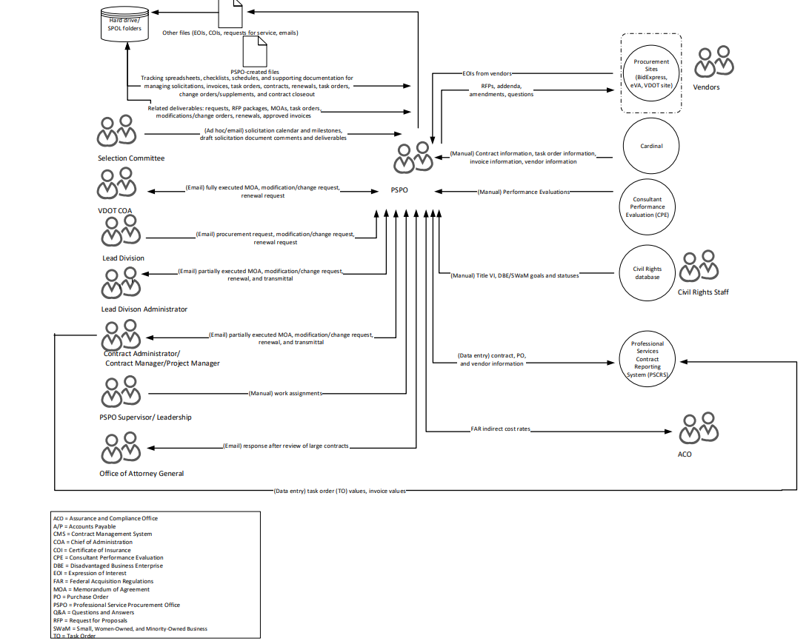

Desired State Diagram - #942

Desired State Diagram - #1140

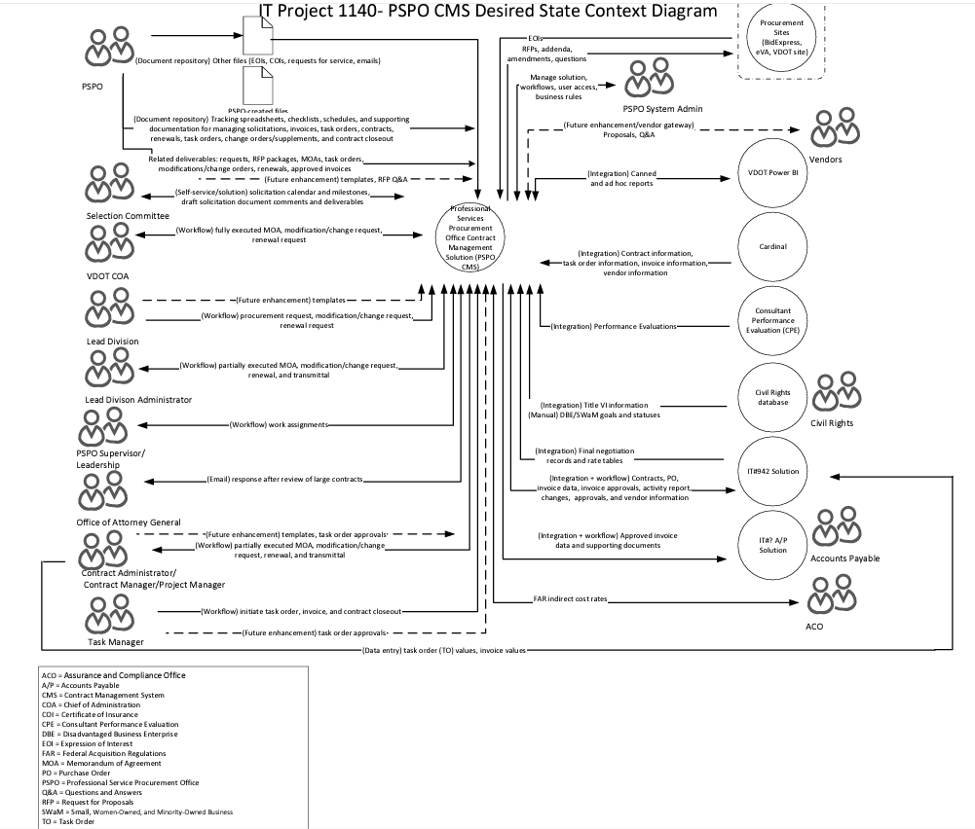

Future State Diagram:

We may eventually decide to deploy additional Dynamics 365 applications to the same environment, however, for now, the desired state is for this solution to have its own environment.

That said, we would like to prepare the environment to possibly create a complementary application in the same environment in the future. This would include making security groups and roles that are specific to this application (among other things).

We are open to third party connectors but would prefer a solution that does not use them.

**PLEASE NOTE: VDOT has provided a number of attachments to help Suppliers responding to this SOR. Please email Christy Butcher at CAI (Christy.Butcher@cai.io) to receive the zip file containing these attachments.**

1. **Period of Performance:**

Delivery of all products and services defined in the Statement of Work will occur within 15 months of project execution date.

1. **Place of Performance** (Check one)**:**

Authorized User’s Location

Supplier’s Location

Authorized User’s and/or

Supplier’s Location (see below explanation)

Authorized User will not provide any facilities or equipment for this SOR.  Supplier resources will work remotely in the cloud using virtual desktops provided by Authorized User. Supplier will request Commonwealth of Virginia accounts for identified resources.  These resources will be subject to backgrounds checks.  All Supplier resources must be individuals subject to United States law and be located within the continental United States.  Non-United States resources are not permitted.

1. **Project Staffing**
2. **Supplier Personnel** (Check One)**:**

The roles listed in the table below represent the minimum Supplier personnel requirements for this engagement. The Supplier shall provide resumes for all proposed personnel.

|  |  |  |  |  |
| --- | --- | --- | --- | --- |
| **Role** | **Technical**  **Skills Required** | **Years of Experience** | **Certifications**  **Required** | **References Required**  **(Y/N)** |
|  |  |  |  |  |
|  |  |  |  |  |
|  |  |  |  |  |

Supplier shall propose the roles and skillsets of the resources needed to deliver the scope of work as defined in this SOR. Supplier shall provide resumes for all proposed personnel.

PLEASE NOTE: The use of offshore resources for any SOW is prohibited.

1. **Authorized User Staff**

The roles listed in the table below represent Authorized User’s staff and the estimated time each will be available to work on the project.

|  |  |  |
| --- | --- | --- |
| **Role** | **Description** | **% Project Availability** |
| Project Manager | Management of supplier engagement | 100% |
| Subject Matter Experts | Provide business knowledge and expertise | 25% |
| Infrastructure Personnel | Assist supplier in establishing environments needed at VDOT | As needed |
| Operations Personnel | Assist supplier in deployment of application, etc. needed at VDOT | As needed |
| Integration Support | Assist in integration of supplier application to specified data sources | As needed |

1. **Milestones and Deliverables:**

The minimum required milestones and deliverables, and the estimated completion date for each deliverable, are listed in the following table.

| **#** | **Milestone**  **Event(s)** | **Deliverable(s)** | **Estimated Completion Date** |
| --- | --- | --- | --- |
| 1 | Kickoff meeting | Project management charter, schedule, project approach | November, 2024 |
| 2 | Requirements Validation/ Finalization | Signed requirements document | Vendor to Propose |
| 3 | Time-boxed Sprints | Incremental delivery of functionality | Vendor to Propose |
| 4 | User Acceptance Testing | User testing of functionality provided | Vendor to Propose |
| 5 | Final Application Acceptance | Signoff on functionality by the business | Vendor to Propose |
| 6 | Post-Production Support | Support beyond the delivery of the functionality | Vendor to Propose |

The Supplier should provide all deliverables in electronic form, using the following software standards (or lower convertible versions):

|  |  |
| --- | --- |
| **Deliverable Type** | **Format** |
| Text Document | Microsoft Office 365 or compatible |
| Spreadsheets | Microsoft Office 365 or compatible |
| Presentations | Microsoft Office 365 or compatible |
| Project Management | Microsoft Office 365 or compatible |
| Code and/or Scripts | Microsoft Azure DevOps entry (additional files attached as needed) |
| Test Scripts | Microsoft Azure DevOps entry (additional files attached as needed) |

1. **Travel Expenses**

Supplier travel expenses, if required, must be included in the total fixed price of the solution

**PLEASE NOTE:  While VDOT is assuming remote work, we may request onsite presence by key personnel as needed.  Since travel must be included in the fixed price, respondents to this SOR should provide assumptions in their SOW responses for how much travel has been included in the fixed price.**

1. **Payment** (Check all that apply)**:**

Payment made based on successful completion and acceptance of deliverables

All payments, except final payment, are subject to a *(XX)*% holdback

1. **Acceptance Criteria:**

The Project Manager will have *10* business days or a mutually agreed upon timeframe from receipt of each deliverable to provide Supplier with the signed acceptance receipt.

Final acceptance of services provided under the SOW will be based upon (Check one):

User Acceptance Test

Acceptance Criteria for this solution will be based on a User Acceptance Test (UAT) designed by Supplier and accepted by Authorized User. The UAT will ensure that all of the functionality required for the solution has been delivered. The Supplier will provide the Authorized User with a detailed test plan and acceptance checklist based on the mutually agreed upon UAT plan. This UAT plan checklist will be incorporated into the SOW.

Final Report

Acceptance criteria for this solution will be based on a final report. In the SOW, Supplier and Authorized User will agree on the format and content of the report to be provided to Authorized User for final acceptance.

Acceptance of all individual deliverables

1. **Project Roles and Responsibilities:**

|  |  |  |
| --- | --- | --- |
| **Responsibility Matrix** | **Supplier** | **Authorized User** |
| Project Management, Planning and Requirements Elicitation & Development. to deliver agreed upon documented scope | ü | ü |
| Solution Design | ü | ü |
| Develop test cases | ü |  |
| User Guide with step-by-step instructions with screenshots | ü |  |
| SIT/Unit Testing | ü |  |
| User Acceptance Testing |  | ü |
| Transition and Deployment to Prod | ü | ü |
| UA Tester and Train-the-Trainer training | ü |  |
| Create and deliver training and documentation for end users |  | ü |
| Post implementation Warranty Services | ü |  |
| 3 months Production Maintenance and Support for the immediate post-deployment period | ü | ü |
| On-going Production Maintenance and Support in the post-deployment period |  | ü |
| Provision the MS Dynamics 365 platform |  | ü |
| Provide Supplier with access to network and development, and test environment access |  | ü |
| Local network access Authorized User premises |  | ü |
| Server Hardware |  | ü |
| Server Operating |  | ü |
| Server Network Connectivity |  | ü |
| Installation, configuration and user provisioning of Microsoft Azure DevOps environment |  | ü |
| Installation, configuration and user provisioning of SharePoint Team site |  | ü |
| Server Modules – Installation and Implementation |  | ü |
| PC Workstations – Hardware, OS (as needed) | ü |  |
| PC Workstations – Client Software (as needed) | ü | ü |
| Keyboard, Mouse, Monitor on Supplier Premises | ü |  |
| Problem Tracking | ü | ü |
| Troubleshooting – IT Infrastructure |  | ü |
| Troubleshooting – Solution | ü |  |
| Troubleshooting – Supplier network and premise equipment | ü | ü |

1. **Criminal Background Checks and Other Security Requirements (**Check all that are required):

Standard CAI Required Background Check

Agency Specific Background Check – VDOT fingerprinting

1. **Performance Bond** (Check one)**:**

Required for *(XXX)*% of the SOW value

Not Required

1. **Reporting** (Check all that are required):

**Weekly Status Update**

The weekly status report, to be submitted by Supplier to Authorized User, should include: accomplishments to date as compared to the project plan; any changes in tasks, resources or schedule with new target dates, if necessary; all open issues or questions regarding the project; action plan for addressing open issues or questions and potential impacts on the project; risk management reporting.

**Other(s)** (Specify)

1. **Federal Funds** (Check one):

Project will be funded with federal grant money

No federal funds will be used for this project

1. **Training and Documentation:**
2. **Training is:**

Required as specified below

Training Requirements:

Supplier will provide training to end user acceptance testers and end user trainers on the implemented technical solution to Authorized User designated personnel for the architecture built through this effort. VDOT anticipates training for no more than 15 people.

1. **Documentation is:**

Required as specified below

Documentation Requirements:

* High level design document that includes details of foundation components of the system
* Other technical documents as described in the EASSOR.
* Documents that provide instructions on how to operate the system, including an Operations Manual.
* System maintenance guide describing any ongoing maintenance tasks needed to keep system operating correctly.
* User Guide with step-by-step instructions with screenshots.
* Testing scripts documented within Microsoft Azure DevOps environment
* Release note documentation as needed to support delivery of each sprint build as well as final implementation details.
* Implementation documentation to include table and field level “Create” and “Back-out” scripts for Database as well as requirements for implementation, release levels, etc.
* Release documentation regarding what stories and functions are included in each release with a final release document describing all functions included.
* Sprint Plan detailing expected stories to be completed
* Sprint demo detailing functions and stories associated with each demo
* Use cases associated with each function delivered
* Weekly status report
* All configuration deliverables code and configurations will be checked into Authorized User’s Microsoft Azure DevOps environment. Developers will check deliverables in and out daily unless otherwise agreed with Authorized User.
* Defects will be tracked in a SharePoint list for defects found by users.  Defects are tracked in AZURE DEVOPS when assigned to developers for remediation.
* Supplier must adhere to the stated process, documentation, and other deliverables as stated in the agreement.

1. **Instructions Regarding Freedom of Information Act and Public Availability/Inspection of Records**

Authorized User reserves the right to use, copy, and reproduce all submitted documents, data, and other information in any manner Authorized User may deem appropriate in evaluating the fitness of the solution(s) proposed, and in complying with applicable law. All data, materials, and documentation originated and prepared for Authorized User shall be subject to public inspection in accordance with the *Virginia Freedom of Information Act*.

Consistent with the Code of Virginia, Authorized User will, as permitted by law, hold confidential trade secrets or proprietary information that is submitted by a Supplier in connection with the transaction contemplated by this SOR if the Supplier, to Authorized User’s satisfaction:

1. invokes the protections of the Code of Virginia in writing prior to or upon submission of the data or other materials,
2. identifies specifically the data or other materials to be protected, and
3. states the reasons why protection is necessary.

**FAILURE TO COMPLY WILL RESULT IN THE DATA OR OTHER MATERIALS BEING RELEASED TO SUPPLIERS OR THE PUBLIC AS PROVIDED FOR IN THE VIRGINIA FREEDOM OF INFORMATION ACT.**

The Supplier will use this form to identify the information that they deem trade secrets or proprietary information. **The designation of an entire proposal or SOR as proprietary or trade secret is not acceptable, and pricing may not be designated as a trade secret or proprietary information.**

**Supplier Trade Secrets / Proprietary Information Designations Table**

| **SOR/Other Document** | **Section/Page** | **Trade Secret / Proprietary Information** | **Reason** |
| --- | --- | --- | --- |
|  |  |  |  |
|  |  |  |  |
|  |  |  |  |
|  |  |  |  |
|  |  |  |  |
|  |  |  |  |
|  |  |  |  |
|  |  |  |  |
|  |  |  |  |
|  |  |  |  |

1. **Additional Terms and Conditions:**

The services to be provided are subject to the following additional provisions:

1. Effective July 1, 2020, the Code of Virginia requires contractors with the Commonwealth who spend significant time working with or in close proximity to state employees to complete sexual harassment training.  As a result of the new code, VITA and the Department of Human Resource Management (DHRM) are requiring that all contractors working through the CAI contract complete DHRM's "Preventing Sexual Harassment" training.  This training is available as either a short video or a written transcript on the DHRM website: <https://www.dhrm.virginia.gov/public-interest/contractor-sexual-harassment-training>. The selected Supplier must agree that any assigned resource will complete the training.
2. VDOT requires contractors to complete the Commonwealth Security Awareness training. The selected Supplier must agree that any assigned resource will complete the training.
3. The selected Supplier must agree that any assigned resource will review and conform to the IT Contingent Labor Program (ITCL) Contractor Code of Conduct. The Code of Conduct can be reviewed on VITA’s website at the following link:

<https://www.vita.virginia.gov/media/vitavirginiagov/supply-chain/pdf/Contingent-Worker-Code-of-Conduct.pdf>

1. **Scheduled Work Hours:**

8:00AM – 5PM EST, Monday through Friday (excluding state holidays)

1. **Facility and equipment to be provided by Authorized User:**

None.  See Section 12: Place of Performance.

1. **Appendix – Attachments**

All these documents are included in the ZIP file as part of this SOR package:

1. D365 Reference Architecture
2. Enterprise Architecture Supplemental Statement of Requirements PSPO (EA-SSOR)

* Templates Identified in EA-SSOR
* Scope template – not included in ZIP file
* Context diagram
* Business Data Flow Diagram example
* Business Process Flow template
* Data Mapping template
* Data Flow Diagram template

**Project #1140**

1. Business Requirements Document (BRD)

* 1140 PSPO BRD Final Approved – Final Business Requirements
* Embedded Files from BRD
* Current State PSPO Context Diagram
* Desire State PSPO Context Diagram
* RTM Worksheet
* PSPO RFPs Process Map - Current State
* PSPO Contracts Process Map – Current State
* PSPO Change Order – Current State
* PSPO RFPs Process Map - Desired State
* PSPO Contracts Process Map – Desired State
* PSPO Change Order – Desired State
* PSPSO Task Order and Contract Closeout – Desired State (Note – there is no PSPO current process for this activity)
* PSPO Invoice Tracking – Desired State (Note – there is no PSPO current process for this activity)
* PSPO Task Order Tracking – Desired State (Note – there is no PSPO current process for this activity)
* System Roles Worksheet
* Documents Repository Worksheet
* Data Elements Worksheet

1. 1140 PSPO Fit Gap - Analysis Using the Detailed Software Requirements (User Stories and Acceptance Criteria)

**Project #942**

1. Business Requirements Document (BRD)

* 942 PSPO BRD Final Approved – Final Business Requirements
* Embedded files from BRD
  + PSPO Staff Placement and Rate Negotiations Context Diagram– Current State
  + PSPO Staff Placement and Rate Negotiations Context Diagram – Desired State
  + CPFF Pre-Award Selected Template
  + FBR Pre-Award Selected Team Staffing Template
  + Invoice Example – Contract 49425 AECOM
  + Pivot Summaries Example
  + PSPO Rate Negotiations Process – Current State
  + PSPO Rate Negotiations Process – Desired State
  + PSPO Solution Access and Library Development Process – Desired State
  + PSPO Staff Placement Process (swim lanes) – Current State
  + PSPO Staff Placement Process (swim lanes) – Desired State
  + PSPO Term Renewal Agreement
  + System Roles – Desired State
  + Team Roster Template Proposed
  + Team Roster Template – Round 1

1. 942 PSPO Fit Gap - Analysis Using the Detailed Software Requirements (User Stories and Acceptance Criteria).